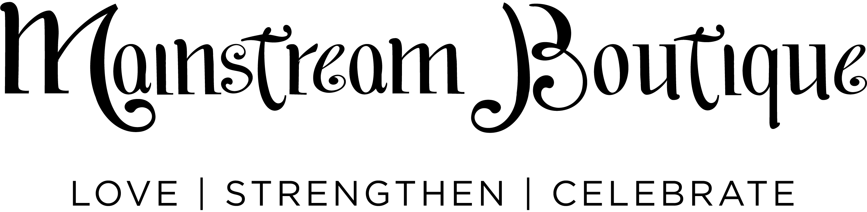

Mainstream Boutique: Stylist Job Description

Position Summary
This position reports to and supports the franchise owner in all assigned aspects of store operations and works with customers on the sales floor.

Responsibilities
Customer Service
- Share our mission to love, strengthen and celebrate customers by delivering the Mainstream Boutique experience online and in-store. (MainstreamU)
- Create a comfortable and welcoming environment, establish genuine connections with customers, offer help with product education, fit, and styling tips.

Product
- Ensure all inventory is checked in and merchandised to sales floor in a timely manner.
- Work with franchise owner to conduct annual physical inventory.

Visual Merchandising
- Merchandise the store in a brand-right manner, using the training on MainstreamU.
Daily: Regularly size, straighten and replenish clothing, basics, denim, shoes, jewelry, and accessories on the sales floor.
Bi-Weekly: Style mannequin displays and tables.
Weekly: Work with franchise owner to remerchandise sales floor and move items to clearance.
- Keep franchise owner up-to-date on needs for broken/damaged furniture, fixtures, or mannequins

Marketing
- Work with franchise owner to execute marketing tactics as requested.
- Assist with event planning and execution and provide customer service during events.

Operations
- Ensure information in the POS is kept up to date and established sales goals are met.

Skills + Abilities
- Customer-focused, organized multitasker who loves the fast pace of retail.
- Passion for fashion and styling with a commitment to execution and attention to detail.
- Action-oriented problem solver accountable for delivering results through effective teamwork.
- Proficient with social media, retail point of sale tools and systems.

Schedule Requirements
- Up to 20 hours/week, including two Saturdays each month and holidays as required

Mainstream Boutique: EMPLOYEE DRESS CODE/DISCOUNTS/RETURNS

Dress Code Standards
As employees of Mainstream Boutique, we are ambassadors of our brand, giving customers an impression of our brand through our actions: How we care for each customer, each other, and our store; our words: What we say when we interact with customers, and what we say about product, events and promotions in the store; and our appearance…We are walking images of the brand in our store, and how we dress can inspire customers. That is why our dress code standards are so important.

- Dress for the season and wear what is currently on the sales floor. Even if there’s snow on the ground in early spring, when we wear spring in the store to show off the new arrivals, customers are excited to buy them, too!

- Hair should be neatly styled and makeup should be applied in moderation. We want the focus to be on our beautiful clothes.

- Avoid clothing that makes a political statement, clothes or shoes you’d wear to the beach or the gym.

Employee Discounts
Let’s be honest – one of the best benefits of a career in fashion retail is the great employee discount. Here’s the information you need to know about how to use it.

- Discount can be used starting on the first day of work (not hire date).

- Employees must wait one week before purchasing new product arriving in the store at a discount. New arrivals may be purchased immediately at full price.

- Discount may not be used to purchase merchandise for anyone (including purchase of gifts for others) other than the employee. Misuse may result in termination.

- Spouses may purchase merchandise for an employee and use the employee’s discount.

- Discount may only be combined with other promotions when determined by owner.

- Completing transactions for your own purchases is not permitted. All employee purchases must be rung through the POS by another Mainstream Boutique employee.

Employee Return Policy
Employees may return merchandise bought at the Mainstream Boutique store where they are employed within seven days for in-store credit or exchange only. Damaged or defective merchandise will be reviewed by the owner to determine if a replacement will be substituted.

Mainstream Boutique: Scheduling Standards

Scheduling
Store schedules are created by the franchise owner four weeks out. Once the schedule is made, any changes must be approved by the franchise owner.

Part-time Hours
Part-time stylists must be available a minimum of three shifts each week and two Saturdays each month. The maximum number of hours allowed for a part-time employee each week is 28.

Arrival & Breaks
Employees may clock-in up to five minutes before a shift. Stylists are allowed a 15-minute break for every four hour shift and a 30-minute paid meal break for six hour shifts.

Covering or Swapping Shifts
If you are sick or cannot work, you are responsible for finding a replacement for your shift. If you swap a shift with another stylist, the shift time must remain the same.

Time Off Requests
Any requests for time off must be made by [deadline] each month.

Busy Seasons & Holidays
We request stylists to be available more often during busy seasons (March-May, September and October, and holidays). Stylists are expected to work at least three holiday weekends each year. Holidays include (New Year’s Eve, Easter, Mother’s Day, Memorial Day, Fourth of July, Labor Day, Thanksgiving, Black Friday, Christmas Eve and the day after Christmas).

Community Events & Parties
Stylists are expected to work at least five Community Events and/or in-store parties throughout the year.

